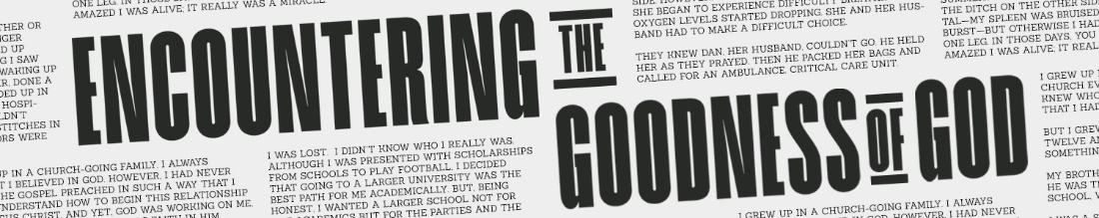

REAL DISCIPLESHIP TRANSFORMS
John 8:30-36

John 8:30-32, ³⁰ Even as he spoke, many believed in him.³¹To the Jews who had believed him, Jesus said, “If you hold to my teaching, you are really my disciples. ³² Then you will know the truth, and the truth will set you free.”

Our Challenge: How do we practice real discipleship
God greatly rewards?

Romans 2:23-24, ²³ You who boast in the law, do you dishonor God by breaking the law? ²⁴ As it is written: “God’s name is blasphemed among the Gentiles because of you.”
Romans 3:1-4, 1 What advantage, then, is there in being a Jew, or what value is there in circumcision? ² Much in every way! First of all, the Jews have been entrusted with the very words of God. ³ What if some were unfaithful? Will their unfaithfulness nullify God’s faithfulness? ⁴ Not at all! Let God be true, and every human being a liar . . .

Exodus 25-31; Malachi 1:11

Real Transforming Discipleship

- Has a DISTINCT SIGN.

John 8:31-32, ³¹ To the Jews who had believed him, Jesus said, “If you hold to my teaching, you are really my disciples. ³² Then you will know the truth, and the truth will set you free.”

- Distinct sign - holding to Jesus’ teaching

- Hold - meno - to abide, dwell and continue

Matthew 28:18-20, ¹⁸ Then Jesus came to them and said, “All authority in heaven and on earth has been given to me. ¹⁹ Therefore go and make disciples of all nations, baptizing them in the name of the Father and of the Son and of the Holy Spirit, ²⁰ and teaching them to obey everything I have commanded you. And surely I am with you always, to the very end of the age.”

John 15:7-8, ⁷ If you remain in me and my words remain in you, ask whatever you wish, and it will be done for you. ⁸ This is to my Father’s glory, that you bear much fruit, showing yourselves to be my disciples.

- Remain - Greek word “meno”- translated hold in John 8:31-32

2 Corinthians 13:5, Examine yourselves to see whether you are in the faith; test yourselves. Do you not realize that Christ Jesus is in you—unless, of course, you fail the test?

John 6:66; Matthew 13:1-23, 36-43, 47-52; Exodus 31:12-13; Malachi 3:17-18

- Brings DESIRED SUCCESS.

John 8:30-32, ³⁰ Even as he spoke, many believed in him. ³¹To the Jews who had believed him, Jesus said, “If you hold to my teaching, you are really my disciples. ³² Then you will know the truth, and the truth will set you free.”

- Free – eleuthero - living exempt from morality that’s a liability

John 8:33-37, ³³ They answered him, “We are Abraham’s descendants and have never been slaves of anyone. How can you say that we shall be set free?” ³⁴ Jesus replied, “Very truly I tell you, everyone who sins is a slave to sin. ³⁵ Now a slave has no permanent place in the family, but a son belongs to it forever. ³⁶ So if the Son sets you free, you will be free indeed. ³⁷ I know that you are Abraham’s descendants. Yet you are looking for a way to kill me, because you have no room for my word.

- The real issue of discipleship is do we have room for HIS WORD in OUR HEART!

John 8:59, At this, they picked up stones to stone him, but Jesus hid himself, slipping away from the temple grounds.

Luke 4:14-30

Questions:
- What did you hear from the Holy Spirit?
- What will you do because of it?
- How can we pray for you?

