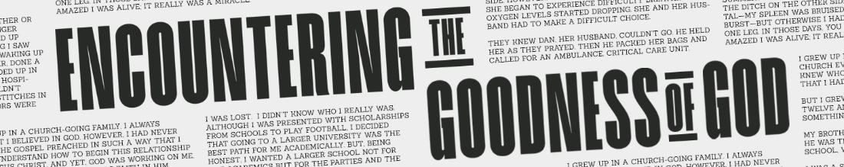

THE TRANSFORMING POWER OF
TRUE WORSHIP
Romans 12:1-2

2 Peter 1:3, His divine power has given us everything we need for a godly life through our knowledge of him who called us by his own glory and goodness.

True worship . . .
- Encounters God’s goodness.
- Grows in the knowledge of God.
- Meets our needs.

“Let me be homo unius libri (a man of one book)” - John Wesley

Why False Worship Doesn’t Work

- False worship doesn’t train our hearts to honor God.

Matthew 15:1-2

Matthew 15:3, Jesus replied, “And why do you break the command of God for the sake of your tradition?

Matthew 15:7-9, ⁷ “You hypocrites! Isaiah was right when he prophesied about you: ⁸ ‘These people honor me with their lips, but their hearts are far from me. ⁹ They worship me in vain; their teachings are merely human rules.’”

- False worship doesn’t train our hearts to obey God.

How To Enjoy Transformational Worship

Romans 12:1-2, ¹ Therefore, I urge you, brothers and sisters, in view of God’s mercy, to offer your bodies as a living sacrifice, holy and pleasing to God—this is your true and proper worship. ² Do not conform to the pattern of this world, but be transformed by the renewing of your mind. Then you will be able to test and approve what God’s will is—his good, pleasing and perfect will.

- True worship must have permission to change our mind and action before it changes our life!
Ephesians 6:1-4, ¹ Children, obey your parents in the Lord, for this is right. ² “Honor your father and mother”—which is the first commandment with a promise— ³ “so that it may go well with you and that you may enjoy long life on the earth. ⁴ Fathers, do not exasperate your children; instead, bring them up in the training and instruction of the Lord.

- True worship TREASURES GOD’S MERCY.

Romans 12:1, Therefore, I urge you, brothers and sisters, IN VIEW OF GOD’S MERCY, to offer your bodies as a living sacrifice, holy and pleasing to God—THIS IS YOUR TRUE AND PROPER WORSHIP.

True and proper – logikos - reasonable, in tune to what is right intellectually and emotionally

Isaiah 55:8-11

1 Timothy 1:13, Even though I was once a blasphemer and a persecutor and a violent man, I was shown mercy because I acted in ignorance and unbelief.

- CONDEMNATION robs us of the blessings of true worship.

- True worship SURRENDERS TO GOD’S LEADERSHIP.

Romans 12:1, Therefore, I urge you, brothers and sisters, in view of God’s mercy, TO OFFER YOUR BODIES AS A LIVING SACRIFICE, holy and pleasing to God—this is your true and proper worship.

- SERVING OURSELVES OR OTHERS robs us of the blessings of true worship.

John 15:9-11, ⁹ “As the Father has loved me, so have I loved you. Now remain in my love. ¹⁰ If you keep my commands, you will remain in my love, just as I have kept my Father’s commands and remain in his love. ¹¹ I have told you this so that my joy may be in you and that your joy may be complete.

- True worship transforms OUR MIND FIRST, METHODS NEXT AND ULTIMATELY OUR MANNER OF LIFE.

Romans 12:2, Do not conform to the pattern of this world, but be transformed by the renewing of your mind. Then you will be able to test and approve what God’s will is—his good, pleasing and perfect will.

- True worship requires us TO CHANGE OUR THINKING AND BEHAVIOR BEFORE IT BRINGS BLESSING.

Questions:
- What did you hear from the Holy Spirit?
- What will you do because of it?
- How can we pray for you?

