Groundnut Project October 2012
Supporting single women headed families to grow fair-trade groundnuts
With funding of £4,000 from Epsom College we were able to start our Groundnut project by supporting 100 women farmers to move from growing tobacco to growing groundnuts. We have linked them to a producer called NASFAM who will give them a guaranteed fair-trade price. These nuts then get sold as ‘Harry’s Nuts’ with the patron being Harry Hill.
Many of these women have between 4 – 8 children to support, so it will make a big difference in their life to be guaranteed an income.
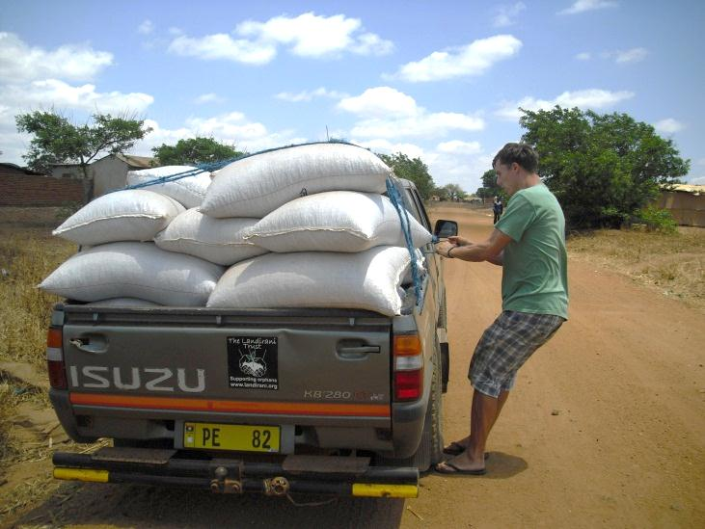
Unfortunately our vehicle broke down at the beginning of the seed distribution and we were saved by a guardian angel who then spent 5 hours driving us around our centres ending up in the dark!
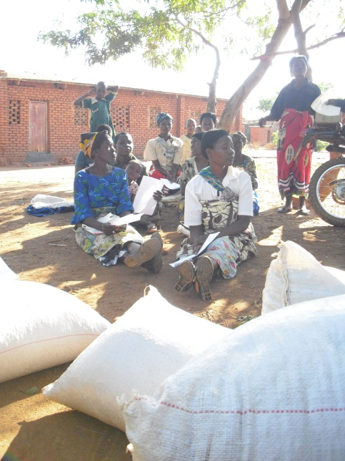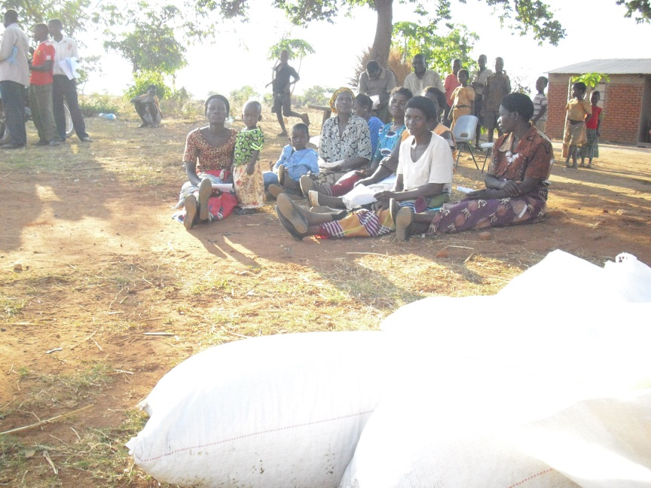
The women formed clubs of with 10 in each and signed an agreement with Landirani. We hope to increase the number of farmers next year to 200.

